Ahmad Siddiq Priaji (22/496854/PA/21370)

Homework 2

1. Rectangle

* Code Rectangle.java

public class Rectangle {

    double width;

    double height;

}

1. Menampilkan infromasi dari objek Rectangle yang direferensikan oleh variable

public class TestRectangle {

    public static void main(String[] args) {

        Rectangle rect0 = new Rectangle();

        rect0.width = Math.random();

        rect0.height = Math.random();

        Rectangle rect1 = new Rectangle();

        rect1.width = Math.random();

        rect1.height = Math.random();

        // (1) start...

        double area0 = rect0.width \* rect0.height;

        double area1 = rect1.width \* rect1.height;

        System.out.println("rect0\n" + "width: " + rect0.width );

        System.out.println("height: " + rect0.height );

        System.out.println("area: " + area0 );

        System.out.println("rect1\n" + "width: " + rect1.width );

        System.out.println("height: " + rect1.height );

        System.out.println("area: " + area1 );

        // ...(1) end

    }

}

Hasil:

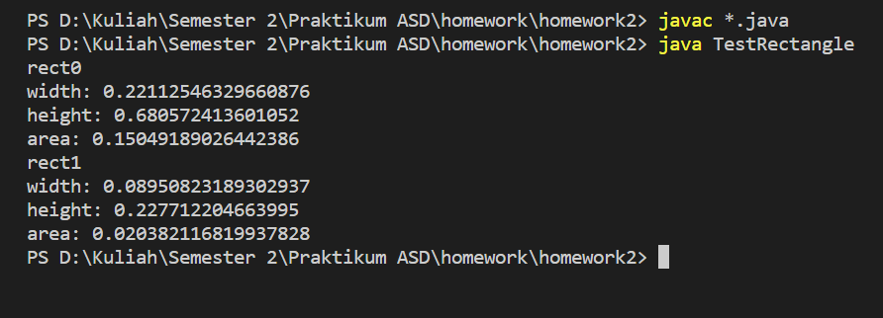

1. Menggunakan array rects

public class TestRectangle {

    public static void main(String[] args) {

        // (2) start...

        Rectangle[] rects = new Rectangle[2];

        double[] area = new double[2];

        for (int i=0; i<2; i++){

            rects[i] = new Rectangle();

            rects[i].width = Math.random();

            rects[i].height = Math.random();

            area[i] = rects[i].width \* rects[i].height;

            System.out.println("rect" + i);

            System.out.println("width: " + rects[i].width );

            System.out.println("height: " + rects[i].height );

            System.out.println("area: " + area[i] );

        }

        // ...(2) end

    }

}

Hasil:

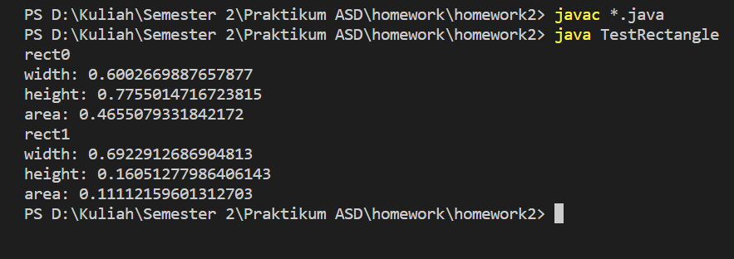

1. Array menyimpan 10 objek Rectangle

public class TestRectangle {

    public static void main(String[] args) {

        // (3) start...

        Rectangle[] rects = new Rectangle[10];

        double[] area = new double[10];

        for (int i=0; i<10; i++){

            rects[i] = new Rectangle();

            rects[i].width = Math.random();

            rects[i].height = Math.random();

            area[i] = rects[i].width \* rects[i].height;

            System.out.println("rect" + i);

            System.out.println("width: " + rects[i].width );

            System.out.println("height: " + rects[i].height );

            System.out.println("area: " + area[i] );

        }

        // ...(3) end

    }

}

Hasil:

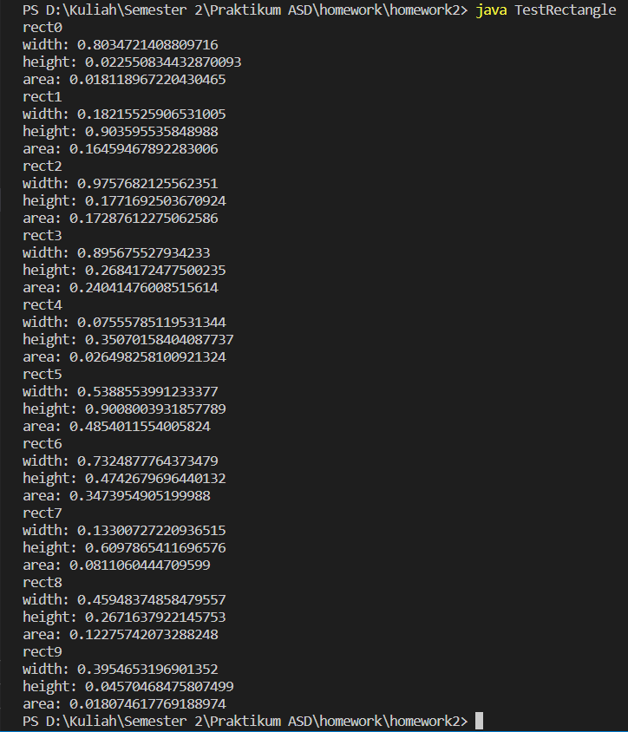

1. Mengeluarkan output informasi Rectangle terbesar dan terkecil

public class TestRectangle {

    public static void main(String[] args) {

        // (4) start...

        Rectangle[] rects = new Rectangle[10];

        double[] area = new double[10];

        for (int i=0; i<10; i++){

            rects[i] = new Rectangle();

            rects[i].width = Math.random();

            rects[i].height = Math.random();

            area[i] = rects[i].width \* rects[i].height;

        }

        Rectangle maxRect = new Rectangle();

        Rectangle minRect = new Rectangle();

        maxRect = rects[0];

        minRect = rects[0];

        for (int i=0; i<10; i++){

            if(area[i] > maxRect.width\*maxRect.height){

                maxRect = rects[i];

            }

            if(area[i] < minRect.width\*minRect.height){

                minRect = rects[i];

            }

        }

        System.out.println("rect" + " terbesar");

        System.out.println("width: " + maxRect.width );

        System.out.println("height: " + maxRect.height );

        System.out.println("area: " + maxRect.width\*maxRect.height );

        System.out.println("rect" + " terkecil");

        System.out.println("width: " + minRect.width );

        System.out.println("height: " + minRect.height );

        System.out.println("area: " + minRect.width\*minRect.height );

        // ...(4) end

    }

}

Hasil:

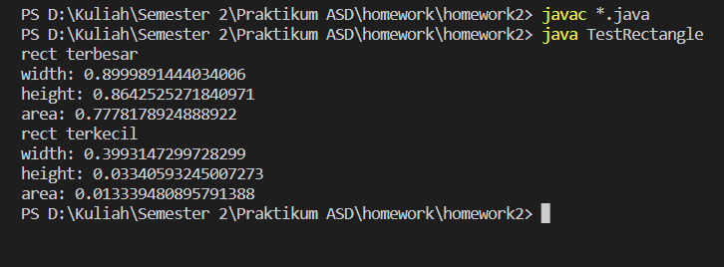

1. Buku

* Code Buku.java

public class Buku {

    String judul;

    String penulis;

    int harga;

}

* Code TectBook.java

public class TestBook {

    public static void main(String[] args) {

        // membuat array yang menyimpan 3 instance Buku

        Buku[] buku = new Buku[3];

        buku[0] = new Buku();

        buku[0].judul = "Introduction to Java Programming and Data Structures";

        buku[0].penulis = "Daniel Liang";

        buku[0].harga = 355000;

        buku[1] = new Buku();

        buku[1].judul = "Advanced Java Programming";

        buku[1].penulis = "Uttam Roy";

        buku[1].harga = 236250;

        buku[2] = new Buku();

        buku[2].judul = "Practical Java Programming";

        buku[2].penulis = "Perry Xiao";

        buku[2].harga = 95000;

        // menghitung harga total termasuk pajak 10% lalu disimpan ke array hargaTotal

        int[] hargaTotal = new int[3];

        for(int i=0; i<3; i++){

            hargaTotal[i] = buku[i].harga \* 110/100;

        }

        // menampilkan infromasi ter-update (judul, penulis, dan harga total)

        for(int i=0; i<3; i++){

            System.out.println("Judul: " + buku[i].judul);

            System.out.println("Penulis: " + buku[i].penulis);

            System.out.println("Harga Total (pajak 10%): Rp" + hargaTotal[i]);

            System.out.println();

        }

    }

}

Hasil:

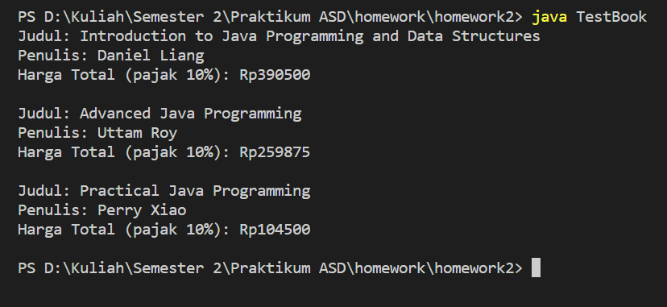

1. Line Length

* Code Point.java

public class Point {

    int x;

    int y;

}

* Code Line.java

public class Line {

    Point p0;

    Point p1;

}

* Code LineLength.java

public class LineLength {

    public static void main(String[] args) {

        Line line = new Line();

        line.p0 = new Point();

        line.p0.x = 5;

        // (task 1)

        line.p0.y = 4;

        line.p1 = new Point();

        line.p1.x = 13;

        line.p1.y = 9;

        double d;

        // (task 2)

        d = Math.sqrt((line.p1.x-line.p0.x)\*(line.p1.x-line.p0.x)

                    + (line.p1.y-line.p0.y)\*(line.p1.y-line.p0.y)

            );

        System.out.println("the legth of the line is " + d);

    }

}

Hasil:



Ahmad Siddiq Priaji (22/496854/PA/21370)

Activity 3.2

Code TestMethod.java

public class TestMethod {

    public static int getRandomNumber() {

        return (int)((Math.random()\*100)+1);

    }

    public static double getAbsoluteValue(double value) {

        if(value < 0) return -value;

        else return value;

    }

    public static int getFactorial(int n) {

        if(n > 1) return n\*getFactorial(n-1);

        else return 1;

    }

    public static String getWeatherForecast() {

        String[] day = {"today", "tomorrow", "the day after tomorrow"};

        int a = (int)(Math.random()\*3);

        String[] weather = {"sunny", "cloudy", "rainy", "snowy"};

        int b = (int)(Math.random()\*4);

        return day[a] + " will be " + weather[b];

    }

    public static String getRandomMessage(String name) {

        String[] greet = {"Good morning ", "Good afternoon ", "Good night "};

        int c = (int)(Math.random()\*3);

        return greet[c] + name;

    }

    public static boolean isEvenNumber(int value) {

        if(value%2 == 0) return true;

        else return false;

    }

    public static double getMinValue(double a, double b) {

        if(a < b) return a;

        else return b;

    }

    public static boolean isSameAbsoluteValue(int i, int j) {

        if(i==j || i==-j || -i==j) return true;

        else return false;

    }

    public static void getMessage(String name, boolean isKid) {

        if(isKid == false) System.out.println("Halo Pak " + name);

        else System.out.println("Halo Dek " + name);

    }

    public static double getSum(double a, double b, double c) {

        return a+b+c;

    }

    public static double getAverage(double a, double b, double c) {

        return (a+b+c)/3;

    }

    public static void main(String[] args) {

        System.out.println(getRandomNumber());

        System.out.println(getAbsoluteValue(-0.398));

        System.out.println(getFactorial(6));

        System.out.println(getWeatherForecast());

        System.out.println(getRandomMessage("Aji"));

        System.out.println(isEvenNumber(5));

        System.out.println(getMinValue(3, 3));

        System.out.println(isSameAbsoluteValue(-4, 4));

        getMessage("Andre", false);

        System.out.println(getSum(0.3243, -1.8212, 100));

        System.out.println(getAverage(0.3243, -1.8212, 100));

    }

}

Hasil:

